 | Climate Change: international links
 | http://climatechange.wmnet.org.uk

Finding out about climate change and sharing experiences and ideas naturally leads to making contact with schools in other countries. Many students and teachers are taking part in projects to compare the local environment, exchange data, hold online debates and compare ideas on climate change. Here are some projects, ideas and organisations that can help.

eTwinning
eTwinning (www.etwinning.net) is a Europe-wide initiative that aims to pair up 35,000 schools in 27 countries by 2007. Since its launch in autumn 2004, nearly 9,000 schools have registered, including 700 from the UK. Once your school is registered, the site keeps your partnerships and progress reports together in one place, saving the need to keep a database elsewhere. The partner schools can also make changes to this so one school does not feel obliged to 'lead' the project.
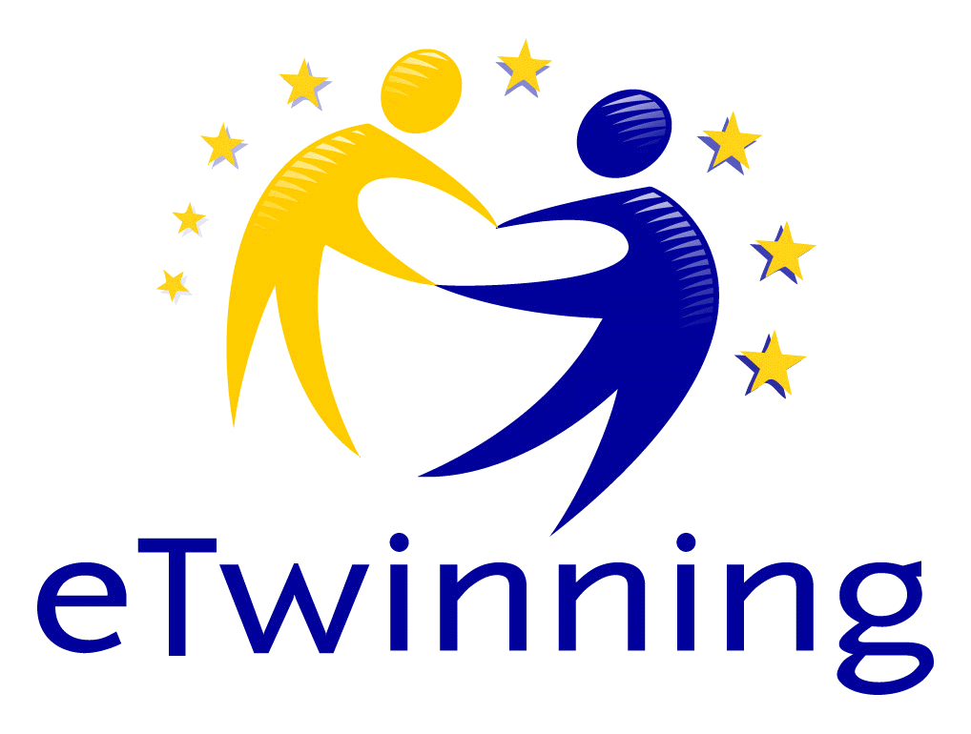
eTwinning is based on joint educational projects via Internet. Sackville School in Sussex has made a ten minute multimedia presentation involving students with special needs in UK and Finland.

Global Gateway
This is the UK’s initiative (linked to eTwinning) to support international links between schools all over the world. Schools from all over the world search for British schools which have pre-registered their interest in an exchange on the site. Likewise, you can browse the foreign schools looking for a partner.

The advantage is seeing exactly what type of project other schools are keen on doing: purely modern languages, geography, multi-disciplinary… It is particularly useful if you want to work across several subjects in your own school. The different sections on the site offer useful guidance to teachers and students on how to develop the link after the initial set-up.
www.globalgateway.org.uk

ePals
ePals is a collaborative network of 4.5 million students and teachers in 191 countries. Students share writing and learning experiences in a safe environment www.epals.com. Regarded as one of the most successful twinning organisations, ePals makes it easy to find a partner class, and provides useful online tools.
Internet safety is the key. Safe e-mail and the ability to create safe web environments for pupils are attractive: teachers can preset which sites pupils should look at for their classroom research, blocking all others.


Globe
GLOBE is a practical environmental education project linking students and scientists in 107 countries.
Over 400 schools in the UK and over 10 Million records world-wide GLOBE encourages pupils to measure aspects of their local environment and report their results over the Internet. Data from schools around the world are then available for pupils to use in a wide range of projects and activities.
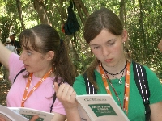

GLOBE aims to:
- Enhance the environmental awareness world wide.
- Increase scientific understanding of the Earth.
- Provide practical opportunities for pupils to increase skills in science, geography, citizenship, maths and ICT.
Web site: www.globe.org.uk

Global SchoolNet

This is a US-based site with lots of ideas and ways to support engagement and collaboration. The projects registry is searchable by keyword and gives a flavour of the range of international partnership activities.
www.globalschoolnet.org

European Schoolnet
European SchoolNet provides a portal for schools in Europe (www.eun.org). Projects like myEUROPE and Spring Day in Europe often include activities related to climate change and the environment. A newsletter for teachers, with a circulation of 40,000, often includes calls for partner schools to work on climate-related projects; subscribe at http://eschoolnet.eun.org. You can create online communities for as few as three partner schools at no charge at http://community.eun.org. xPlora (www.xplora.org) is a science portal leading to places and projects, some of which relate to climate change, for example Environment Online at http://eno.joensuu.fi, a Finnish project which runs four themes through the school year, one of which is “This is our nature”.

Video-conferencing
International video-conferencing via ISDN has long been possible and in daily use. The Global Leap site provides comprehensive guidance and links.
A new service using the National Education Network (to which WMnet schools are connected) enables schools to video-conference safely and reliably. Because the communication uses Internet Protocols, there are no usage costs, unlike ISDN video-conferencing. To use this service schools should register with the support desk at www.jvcs.ja.net/schools. A video-conferencing directory is in preparation to help schools identify potential partners.
Global Leap site: www.global-leap.com.

IECC
IECC is a free teaching.com service to help teachers link with partners in other cultures and countries for email classroom pen-pal and other project exchanges. Since its creation in 1992, IECC has distributed over 28,000 requests for e-mail partnerships.
Web site: www.iecc.org

Science Across the World
This subscription service enables students to exchange information, opinions and ideas on a variety of science topics with young people in every continent. Exchanges are possible in several languages. The Global Warming topic is aimed at 14 to 17 years olds. A free six-month trial is offered.
http://www.scienceacross.org

Green Week
This is a series of activities for young people in Europe build around a week of events in May-June. There is a competition for pictures and videos made by young people.
www.greenweek2005.eun.org
Funding
Comenius funding (next deadline 1 February 2006) offers up to €2000 for two different types of foreign trip, details of which can be found on the British Council website (http://www.britishcouncil.org/socrates-sfe-joint-curriculum-projects.htm).
Joint Curriculum Projects provide funding for trips involving at least three schools from three EU countries, up to six staff and four pupils, including a required preparatory visit. Projects are intended to last up to three years, so whole school support for this is wise.
Making links work
Successful international projects often have common features. They:
- Have clear expectations: it is important to discuss in depth when the project will start and finish and what its aims and expected outcomes are, which language will be used when, and matters such as delays between receiving and responding to email
- Have a clear topic in mind and a visible need for communication and information exchange
- Are supported, from the start, by management, teaching and technical staff, pupils and parents
- Are co-ordinated by one person with project management skills]
- Match the abilities of partner groups: in language projects in particular, learners’ ages and their proficiency should be matched carefully
- Recognise cultural differences between countries: different holiday dates, school working days and times of access to e-mail, as well as approaches to innovation and working outside the school day.
More advice can be found at: Learning and Teaching Scotland and Global Gateway.

