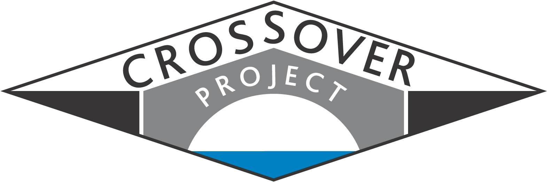 | Crossover  A WMnet collaborative project
Final report: Autumn 2004 |  | www.wmnet.org.uk

Crossover is a Key Stage 2 design and technology project that ran from December 2003 to June 2004. One of a number of projects to receive funding from the Department for Education and Skills and managed by Regional Broadband Consortia, the project was designed to match WMnet’s wider strategy and priorities, particularly focusing on partnership, and innovative content development. It involved pupils and teachers in paired primary schools communicating through appropriate technologies including video-conferencing across a number of LEAs, and leading to a celebration event at Ironbridge that would be accessible on-line for the participating schools. Partners included WMnet and its 14 constituent LEAs (with a lead being taken by Birmingham, Telford and Wrekin, and Shropshire LEAs), Enginuity, the University of Central England, and Imagineering.

Scope
The idea of the project was to enable pupils to work collaboratively, via an on-line environment, with their peers in other schools, and with support from experts in engineering (through Imagineering), ICT, and design and technology (at the University of Central England, Enginuity and in several local authorities). The project involved 14 schools (one from each WMnet LEA), and they were paired for the required design and technology activities. Each pair was to design and make one bridge and one vehicle as part of their design and technology course. The project brief set out the specification for a new tourist bridge and vehicle to transport tourists who found walking difficult across the Ironbridge gorge. Purposeful electronic communication between paired schools was identified at early stages as being vital to overcome an intentional information gap: to ensure that details such as bridge width would enable the vehicle to traverse the gorge.

It was intended that the project would provide a framework of innovative activities, making use of the regional broadband network, and that new communication and learning opportunities through the use of ICT tools would arise. The project was designed in an open-ended way to take advantage of emerging opportunities and the expertise of a number of partners.

Preparation
Schools identified by LEA design and technology advisers were paired and each school was designated either as a school working on the vehicle, or a school working on the bridge. Schools tended to be strong on design and technology but not necessarily so in ICT.

Representative teachers were involved in a professional development day (in March 2004) and a support toolkit was produced including a video to set the scene and the task and a photo montage and links to web sites.

A support toolkit was produced including a video to set the scene and the task and a photo montage and links to web sites.

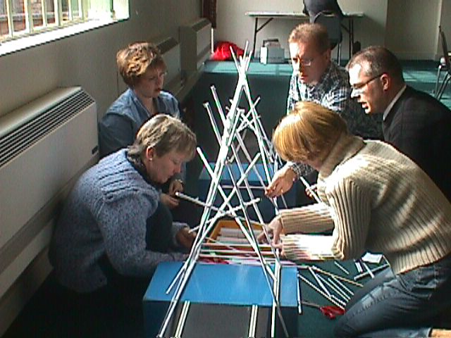
Bridge-building teachers at the CPD day

During the project the project administrator produced a weekly newsletter with stories, hints and advice. For example, pairs of schools were asked for a team name and a UCE student volunteered as an online ‘disability expert’, because of her father’s disability.

Pupil activity
Work was undertaken in the fourteen schools in May and June 2004. To complete the project, key uses of ICT were:
- Video and email links to enable pupils and teachers to exchange problems and solutions using text, images, plans and graphics
- A web-based community area on the WMnet portal for pupils, teachers and experts
- Tools for capturing processes (digital video camera, digital camera, PowerPoint)
- Laptop access and links.

The Celebration Day
A celebration event at Enginuity, Ironbridge on 22 June 2004 enabled representatives from each group to show their work and test the outcomes of their collaborative undertakings – the first time pupils had met face to face. During the celebration event each pair of schools had to make a joint presentation (in all cases schools chose to use PowerPoint) about the process and run the vehicle over the bridge in front of all present. Awards were given for performance and excellence in a range of areas.

Those schools that had been able to communicate with each other before the event were certainly able to work together more readily at the event than those that had not managed this. There appeared to be a direct relationship between the ease and comfort of working together and the amount of email correspondence before the event.

A local media company, C21VOX, filmed pupils in two of the schools as they prepared for the event and broadcast recorded and live highlights from the day back to schools over the broadband network.

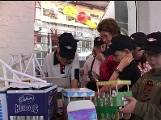
The Celebration Event
Following the celebration event school activity diminished but some schools made displays about the project and others were featured in local newspapers. The project web site, mainly providing internal project support during the active phase, was turned into a project archive and resource area containing materials and guidance to enable others to replicate the project.

Evaluation
Don Passey (University of Lancaster) evaluated the project and reported that:
- Crossover is an innovative project that has given rise to some key outcomes when broadband technologies are used to support collaborative activities
- Email has allowed pupils to share both at a project and at a personal level. Team approaches have been developed so that pupils in different locations have worked seamlessly.
- The use of video and digital cameras has been high. Pupils have often excelled in creating presentations
- Broadband has played a significant role. Research is easier when access is reliable and speeds are high; images and videos can be accessed as well as text. In this subject, video and image exemplification is essential, and broadband enables access to such resources. Sharing has also been supported by broadband: pupils have been able to exchange diagrams, photos and videos.
- Web-casting via the national education network is an important means to address child protection, privacy, parental concerns and associated issues.

Effective practice identified in the project included using video to introduce a project to teachers and pupils and Ask the Expert facilities to enable teachers and pupils to ask questions that would otherwise remain unanswered. Sending images enables more focused questions to be asked. Also effective were classroom displays about the project, the tasks, news, photos and messages.

Key issues arising were:
- The regional broadband infrastructure is not yet able to support video-conferencing or web-casting easily.
- Email procedures and restrictions in some schools seriously inhibit collaboration and good practices.
- Collaborative projects require careful matching of schools using a variety of criteria.
- Teachers need to be aware early on of ways ICT can support a subject project and subject objectives
- Little communication between schools tends to lower educational, social and behavioural gains
- Quality of access to online facilities is affected by many features in current communication systems.

Among the recommendations are that::
- Teachers and pupils should have a clear understanding of how ICT can be used to communicate, research, support, record work and present outcomes.
- Web sites that enable pupils to research aspects of the topic should be shared with others early on.
- Judging criteria need to be available to pupils and teachers well in advance of any project event.
- Email and video-conferencing between schools should be encouraged to enhance collaboration and sharing at educational, social and behavioural levels.
- Technical and administrative barriers to access to web-casts and other on-line facilities, e.g. firewalls, should be identified and addressed.

Wider adoption would need to ensure participating schools had access to a broadband infrastructure and reliable and high quality online facilities. Matching of schools should include access to ICT facilities and user competences. There should be early discussions about ways in which ICT can be integrated into a subject project to support subject objectives.

In the light of the positive evaluation report, the project is continuing, - on a larger scale and aiming to tackle some of the issues raised in the evaluation. For further details please contact jean.maund@wmnet.org.uk.

WMnet gratefully acknowledges the commitment, professionalism and enthusiasm of all involved in the Crossover project.

