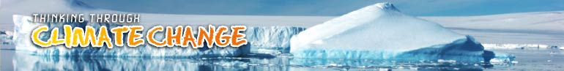

- LEARNING LOG

Name
Date

What have I learned about climate change worldwide?
Where have I learnt it from?
What will I report back on?
Who is responsible for climate change? What might they do?
My personal feelings

You might want to share these ideas with other learners:

- Don’t forget to save this file in your personal folder.
- Is there anything you want to save with it?

To return to the learning materials click here
To go on to the next activity click here
To start your final report click here

